FTF FY 2023 Performance Scorecard USAID Ghana

This Feed the Future (FTF) Performance Scorecard assesses the USAID Ghana progress toward FY 2030 Performance Targets.

# Performance Overview



The FY 2023 **On track** value is determined by drawing a line from the baseline (FY 2022) to the FY 2030 Target. For FY 2023, Performance Targets are considered **On track** if they have reported at least 90% of that value.

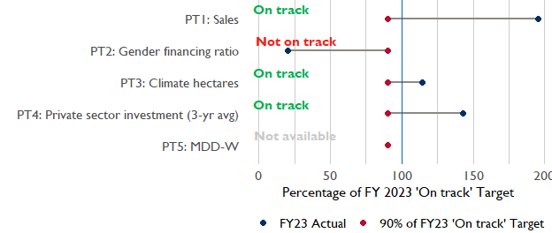

**Note:** *For Performance Target 2 (Gender financing ratio), the target is to increase financing to females for those OUs that are already achieving parity ($1).*

*For Performance Target 4 (PSI), all targets are relative to the last three years’ reporting. In future years, the interim targets may increase.*

*For Performance Target 5 (MDD-W), all FY23 actual values are also the baseline, and may have been collected in a prior year. See the detail page for more information.*

*See detailed* [*methodology document*](https://docs.google.com/document/d/13n-43ppFiGKauscQ7HaAiQDCM4DssGEgRdq2fMyTDn0/edit) *here. If you have questions, please email the FTF Data and Analytics team at* [refs.adl.da@usaid.gov](mailto:refs.adl.da@usaid.gov).

### Performance Target (PT) Details

This section shows PT scores for each applicable PT for USAID Ghana.

## Performance Target 1: Value of annual sales of producers and firms receiving USG assistance



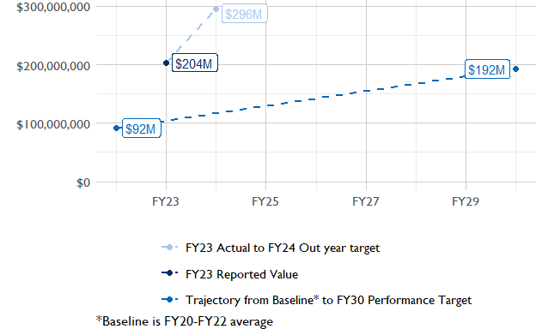

In FY 2023, USAID Ghana had 5 activities that aligned the ‘Value of annual sales from producers and firms receiving USG assistance’ (EG.3.2-26), and 4 contributed to the sales total of $203,670,000.

###### Performance Target 2: Value of financing accessed by female FTF participants per $1 of financing accessed by male FTF participants



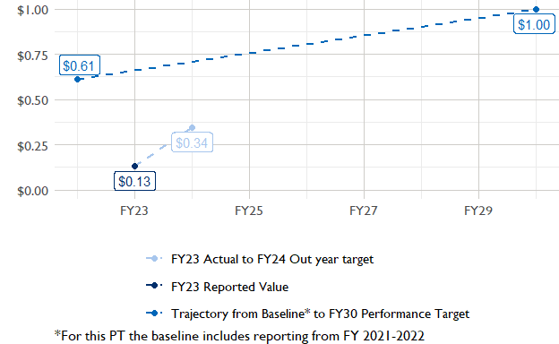

In FY 2023, USAID Ghana had 5 IMs/Activities that reported all four sex disaggregates needed to contribute to PT2. The total value of financing among all activities, regardless of disaggregates, was $58,590,000 (EG.3.2-27 total), with $58,590,000 that was disaggregated by females and males, and an additional $8,930,000 to ‘mixed’ firms that have both males and females, and $10,000 that was not sex disaggregated.

###### Performance Target 3: Number of cultivated hectares under climate adaptation/climate risk management practices and technologies with USG assistance



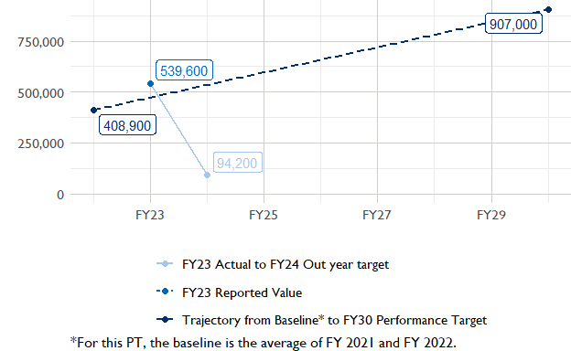

In FY 2023, Ghana had 12 activities that aligned the indicator for hectares under improved management practices (EG.3.2-25). Of those activities, 3 reported on the ‘Climate adaptation/climate risk management’ disaggregate and contributed to the OU total for this PT.

###### Performance Target 4: Value of private sector investment leveraged by the USG to support food security and nutrition



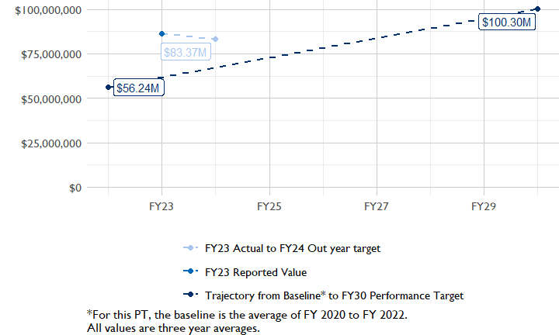

In FY 2023, Ghana had 4 activities that aligned the private sector investment indicator (EG.3.1-15/-14), ‘Value of new private sector investment leveraged by the USG to support food security and nutrition [IM-level]’, and 3 contributed to the OU total in FY 2023.

###### Performance Target 5: Percent of women consuming a diet of minimum diversity (MDD-W)



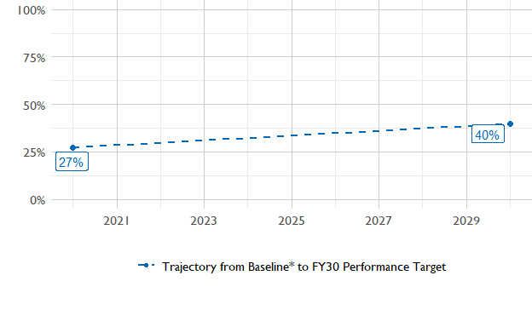

The baseline population-based survey (PBS) for USAID Ghana was in 2020 and showed that 27% of women in the ZOI had access to a minimally-diverse diet. The FY30 target is 40% percent.The most recent PBS was in 2023, but results are not yet available. The following PBS is scheduled for .

### National Context

National level data was collected from the [World Bank’s Open Data portal](https://data.worldbank.org/) that measures key indicators at the national level.

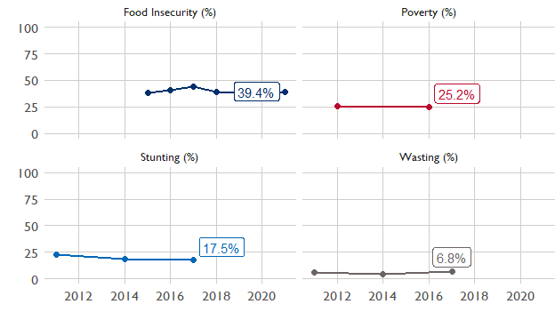

## Agricultural Transformation Index Score

The [IFPRI Agricultural Transformation Index (ATI)](https://agrilinks.org/events/drivers-agrifood-system-transformation-lessons-feed-future-country-studies) Score is a high level indicator of the status of agricultural market systems in each country.

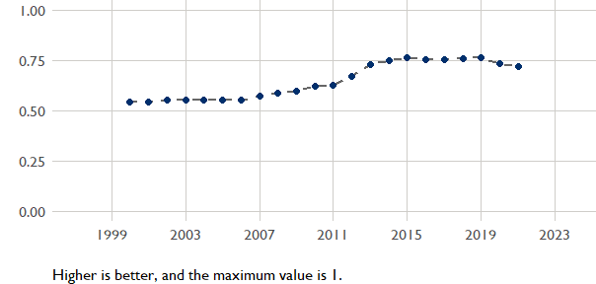

## Budget Trend

At the Operating Unit level, the Performance Targets are based in part on the FY 2024 budget request. The budget chart below includes EG.3 money only.

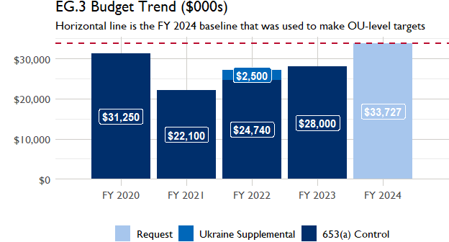

## Active Portfolio

The following activities are considered “active” based on their reporting in FY 2023 and expected FY 2024 reporting. The Analytics, Data and Learning Division defines an “active” activity as one that reported targets, actuals, or deviation narratives for the current year (FY 2023), or the next out year targets (i.e. FY 2024).

## Top Activities (Award Disbursements and Results)

This section highlights some activities in the USAID Ghana (GHANA) portfolio that have the highest level of disbursements and high reporting values for the relevant indicators. The table below shows the top (up to) five activities by the total transaction amount for disbursements. The columns to the right indicate if these activities are reporting on relevant PT indicators.

| Award Number | Activity Code | Activity Name | FY23 Disbursements | PT1 | PT2 | PT3 | PT4 |
| --- | --- | --- | --- | --- | --- | --- | --- |
| 72064122C00001 | 5005 | Feed the Future Ghana Market Systems and Resilience Activity | $7,080,380 | X | X | X | - |
| 72064120C00003 | 1851 | Feed the Future Ghana Mobilizing Finance in Agriculture | $6,726,686 | X | X | - | X |
| AID-OAA-A-17-00029 | 2406 | AGRA-Partnership for Inclusive Agricultural Transformation in Africa | $3,728,871 | - | - | X | X |

**The next table (below) shows the top reporting activities.**

| Award Number | Activity Code | Activity Name | Total Disbursements | Sales | Hectares | PSI |
| --- | --- | --- | --- | --- | --- | --- |
| 72064120C00003 | 1851 | Feed the Future Ghana Mobilizing Finance in Agriculture | $6,726,686 | $166,854,305 | NA | $50,163,805 |
| 72064122C00001 | 5005 | Feed the Future Ghana Market Systems and Resilience Activity | $7,080,380 | $21,728,234 | 4 345 | NA |
| 72062019C00003 | 1097 | West Africa Trade Hub | $1,520,444 | $10,601,032 | NA | $9,373,342 |
| 72064121C00002 | 5330 | Feed the Future Ghana Trade and Investment Activity | $1,898,520 | $4,485,809 | NA | NA |
| AID-OAA-A-17-00029 | 2406 | AGRA-Partnership for Inclusive Agricultural Transformation in Africa | $3,728,871 | NA | 532 962 | $32,000,000 |

### Appendix 1: Response to “Not on track” Performance Targets

This section provides space for USAID Ghana to provide an explanation of why the following PTs are not on track and how you could adjust to be on track in the coming year(s). To help in your response(s), the relevant section of the FTF/GFS Key Issue Narrative (KIN) is provided, as it *may be* useful in drafting a responses. Note that the KIN is addressing the sum of the out year targets (FY 2023) set by the USAID Ghana activities that are reporting on each PT. The FY 2023 out year targets were set prior to the establishment of the FY 2030 Performance Targets, so the below explanations from the KIN may not apply to the Performance Target deviation.

* In Section 4 of the FTF KIN, your OU discusses FY24 and FY25 targets, while these Scorecards are addressing progress against a trajectory from historical reporting to your OU’s FY30 target.  Also, the FY 2023 out year targets were set prior to the establishment of the FY 2030 Performance Targets.  Therefore, the below explanations from the KIN may not apply to these FY30 Performance Target deviations.
* These responses will be used to compile a Congressional report, the GFSS Implementation Report, to discuss progress against the FTF FY 2030 Performance Targets, as mandated by the GAO.
* Only PTs that are ‘Not on Track’ require review and explanation from the OU.

## Performance Target 2: Gender financing ratio

*Excerpt from FY23 KIN Section 4 to consider:* deviation in gender parity in access to finance was driven by the FTF Mobilizing Finance in Agriculture (MFA) activity. The experience of our programming in access to finance is that the dollar amounts sought by female borrowers is currently much lower than that of men. Overall, however, we are seeing more individual loans made to women than to men. N/A As adjustments to address this, we will seek ways through MFA to both increase loan sizes for women who want larger loans, and through increasing the total number of loans to women. The follow-on activity to MFA is also in design and we will ensure that performance targets require the partner to achieve parity. N/A as aggregate of FY2024 and FY2025 target value is more than the FY2023 actuals

#### Enter USAID Ghana (GHANA) Response Below: